What is Happening to Me and How Do I Cope with It?
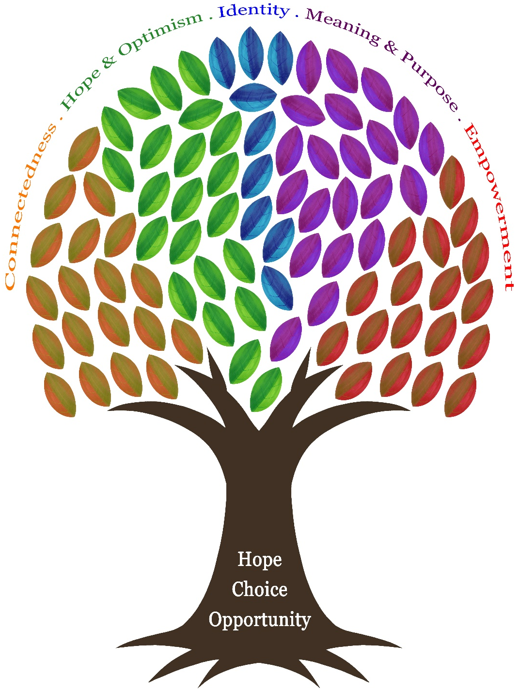

BCHFT 2020


Hope: You Can Get Better!

The Plan:
- 4 sessions to learn skills you can use to help in your daily life.
- Practice in between sessions.
- Practicing after the 4 sessions – this could be on your own, in Mobile Mindfulness sessions or in an Introduction to Emotions group.

What You Need:
- To understand what is happening to you.
- To have the knowledge of the right skills
- Support to implement and practice the skills daily.

How can you improve each of these areas in your life?
Support: Family, Friends, Services
Knowledge of the Right Skills

Practice, Practice, Practice

Our Aims:
- To help you understand what is happening to you and why you are struggling.
- To teach you skills to manage your intense emotions.
- To help you understand that recovery takes time.
- To help you be able to attend one of our courses on offer and/or the Recovery College.

Getting to Know You
Label or draw around the diagram: What do you like to do? What interests have you had? What would you like to do in the future?



What are you Finding Difficult?
Using the boxes below, draw or write what you are struggling with at the moment.
You might include: What you have stopped doing, the thoughts you have or changes in your body.
Extremely Difficult

Very Difficult

Quite Difficult

SMART Goals
Initial Goal: What do I want to see change?


Be Specific: Who can help? Target date? Why is the goal important?

Make it Measurable: How can I measure my progress? How will I know I am successful?


Is it Achievable? Do I have the skills? Is the goal worth the effort?


Is it Relevant? Why set the goal now? Does it align with my broader goals?



Time-Bound: What is the deadline? Is it Realistic?
Final SMART Goal:
What is Going on in My Brain?
Our brains are split into 2 sections: the front brain and the back brain.
Both have very important roles, but we need to make sure the balance is right otherwise our lives can be made more difficult.

Front Brain
- The front brain is made up of the neocortex.
- It helps us to make rational, thought through decisions.
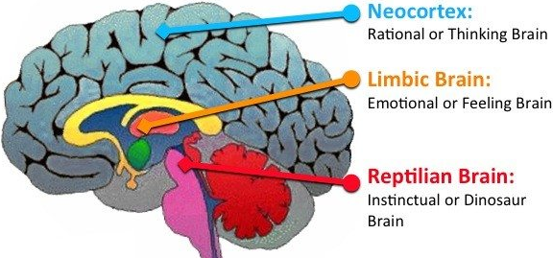
- It is involved in planning and information processing.

Back Brain
- The back brain is made up of the limbic and reptilian systems.
- It is the centre of our unconscious emotions and survival instincts.
- It is responsible for our fight/flight/freeze response.

After Trauma…
- Your back brain will try to keep you safe.
- Your back brain will detect danger that is not there as well as danger that is there.
- You will need to learn skills to calm yourself down – doing this will help you use your front brain more.

The Window of Tolerance – Traffic Light
The Window of Tolerance model helps to describe how you are feeling. When you understand how you are feeling it is much easier to do something about it.
Red (Hypo-arousal) – Feeling numb, ‘out of it’ and like your body wants to shut down.

Yellow (Hyper-arousal) – Feeling overwhelmed and like your body wants to escape or fight.

Green (The Window of Tolerance) – Feeling okay and like you can manage daily life.

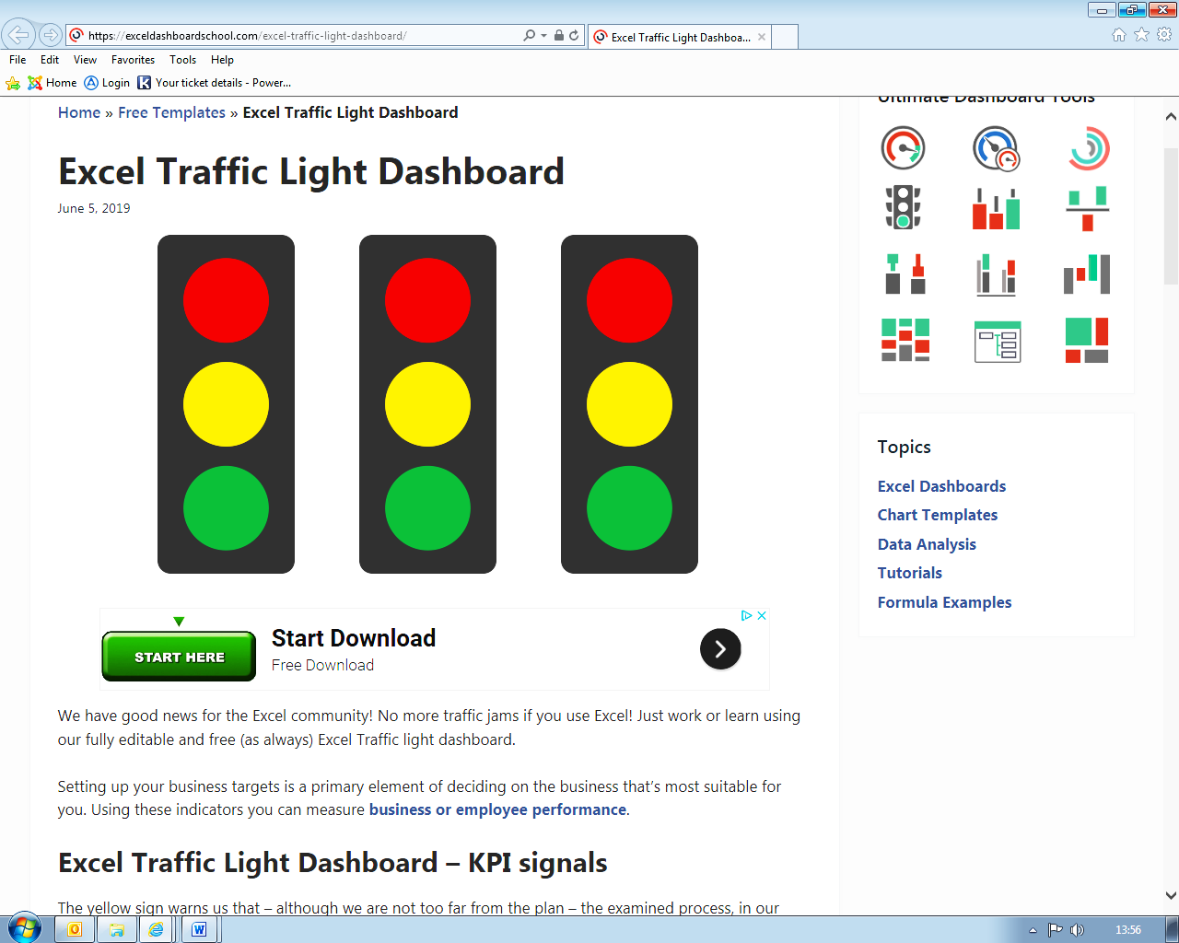
How do you feel?
- Isolated
- De-motivated
- Trapped
- Shame/guilt
- Frozen
- Practice mindfulness
- Talk to someone
- Do little things you enjoy
- Don’t give up!

- Go outside
- Mindfulness
- Deep breathing
- Watch TV/listen to music

- Make a drink
- Mindfulness
- Self-soothe
- Distract yourself
- MOVE!!!

- Make a drink
- Mindfulness
- Self-soothe
- Distract yourself
- MOVE!!!

- Make a drink
- Mindfulness
- Self-soothe
- Distract yourself
- MOVE!!!

- Make a drink
- Mindfulness
- Self-soothe
- Distract yourself
- MOVE!!!

- Under threat
- Anxious
- Agitated
- Pacing
- Fight or flight

- Safety
- Socialising
- Joy
- Motivated
- Productive

What to do?

Here is a blank version of The Window of Tolerance Traffic Light. Use this to keep track of how you are feeling and what you do about it throughout the week. It is okay to be in one, two or all the zones during the day.
How do you feel?
What to do?

Bodily Responses to Trauma
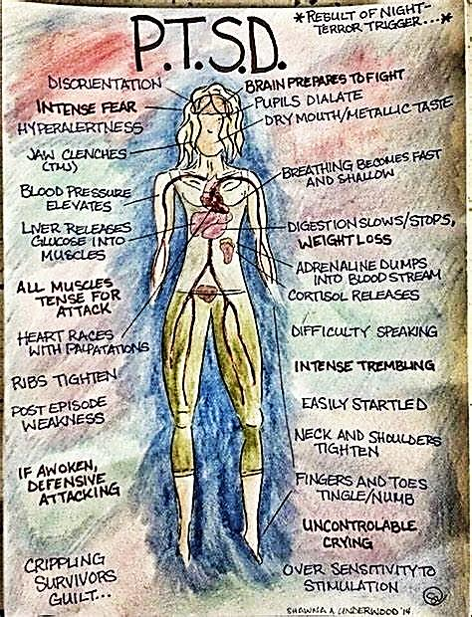

Label any of the bodily responses you experience when you are feeling anxious or low. If you can, write down any triggers that lead to these responses. The more information you gather about these responses, the more understanding you will have.

Breathing Exercises
Taking deep breathes will help you to feel more in control of your body. It can feel strange at first, but with practice you will start to notice the benefits of deep breathing. Below are a few breathing exercises you can try:
Breathe in for 3 counts, holding your breath for 2 counts and breathe out for 4 counts. Repeat.
Take a few minutes to notice your breath. Notice the inhale and exhale. Notice the rise and fall of your belly. Notice how the air feels coming in and out.

Breathe all the air out through your mouth until you feel you must take a deep breath in. Hold the breath and then repeat.

Have a look online for some other breathing exercises you can try. You will like some more than others, so find your favourites and practice those about 4 times a day for 3-4 minutes.

Remember to practice 4 times a day for 1-2 minutes. Keep a record of the exercises you use each day and how they made you feel.
When?
Exercise(s):
How it felt?

When?
Exercise(s):
How it felt?

When?
Exercise(s):
How it felt?
When?
Exercise(s):
How it felt?
When?
Exercise(s):
How it felt?
When?
Exercise(s):
How it felt?
Building Up Your Defences – Skills
In your 4 sessions you will learn a variety of skills to do with grounding, mindfulness and self-soothing. Use the space below to write down the skills. You could also look online for skills other people recommend, try them and note them down too. Build up your wall of defence.
You may find it helpful to rate each session and note any questions you have for the next session. Use the space provided below.
Session 1:

How did you find today?

What are you going to do before next session?

Any comments/questions:

Session 2:

How did you find today?

What are you going to do before next session?

Any comments/questions:

Session 3:

How did you find today?

What are you going to do before next session?

Any comments/questions:

Session 4:

How did you find today?

What are you going to do before next session?

Any comments/questions:

My Safety Plan
How Can I Get Through Right Now?

What Can Make My Situation Safer?

What Can Distract Me?
What Can Calm or Lift My Mood?
Who Can Support Me?
Who Can I Talk to When I Feel Distressed or am Thinking About Harming Myself?
What Professional Support Should I use in an Emergency?
Useful Articles
Carolyn Spring Blog – Blog posts from someone who has experienced trauma and describes herself as recovered. https://www.carolynspring.com/blog/

PODS Articles – These explore various areas of mental health and recovery. https://information.pods-online.org.uk/all-articles/
- Divorcing Old Habits. https://information.pods-online.org.uk/divorcing-old-habits/
- 10 Roadblocks to Recovery. https://information.pods-online.org.uk/ten-roadblocks-to-recovery/
- Be Kind to Yourself: Self-care and the Golden Goose. https://information.pods-online.org.uk/be-kind-to-yourself-self-care-and-the-golden-goose/
- 10 Things I Have Learned about Child Sexual Abuse. https://information.pods-online.org.uk/ten-things-i-have-learned-about-child-sexual-abuse/
- Can we heal? https://information.pods-online.org.uk/can-we-heal/
ReQoL – 10
For each of the following statements, please tick one box that best describes your thoughts, feelings and activities over the last week.
Last Week | None of the time | Only occasionally | Sometimes | Often | Most or all of the time
- I found it difficult to get started with everyday tasks
- I felt able to trust others
- I felt unable to cope
- I could do the things I wanted to
- I felt happy
- I thought my life was not worth living
- I enjoyed what I did
- I felt hopeful about my future
- I felt lonely
- I felt confident in myself

 | No problems | Slight problems | Moderate problems | Severe problems | Very severe problems
Please describe your physical health (problems with pain, mobility, difficulties caring for yourself or feeling physically unwell) over the last week.

