DUDLEY’S COST OF LIVING WEEKLY ROUND UP
31st March 2023

Worrying About Money Leaflet

Please share this leaflet with your service users, colleagues, and partners. Even if they do not need it for themselves, they could find the information useful to share with a family member, a neighbour or a friend who may be struggling.

https://www.worryingaboutmoney.co.uk/dudley

SPOTLIGHT on Dudley’s Action on Poverty Round 2
The Action on Poverty Round 2 Event took place on Monday 27th March at Wellington Road Community Centre.
Dudley Council and DCVS worked together to fund six projects that presented their ideas. The projects will help some of the most vulnerable people in Dudley who are struggling during the cost of living crisis.
A rundown of each project and what they will be providing will be the highlight of this week’s news round up!!
Please find out more below

Jasmine Road Community Gardens
Plot to Plate
We are Jasmine Road Community Gardens, we have launched our Plot to Plate Project to teach people to grow their own produce from start to finish, turning it into tasty meals in order to feed their families & teach cooking skills.
We will be delivering Children’s and Family Cooking Sessions once a week!
We have a plot and polytunnel full of vegetables that people locally can come and have on a “pay as you feel able to” basis with all proceeds going straight back into the project to make it sustainable. We have also recently opened our Community Café/Hub where we also offer a Warm meal project for people locally once a month. This is proving very popular and is supported by Black Country Food Bank as well as our Breakfast Club once a month.
We are in the process of filming a series of short videos with YMCA and Black Country Food Bank where people can pick up a bag to feed a Family of 4. Our Cook along videos will enable them to either cook meals at home if they don’t feel comfortable enough cooking with a group of strangers. We will then encourage the people to substitute the tinned ingredients for fresh produce from us when they feel confident in their cooking skills.
For more information about the project Contact: Donna Haddock
jasmineroadcommunitygardens@gmail.com
Tel: 07760 315346

WeLoveCarers
We Love Carers Warm Centre
Will be providing carers with coffee mornings for two hours per week at
The Mary Stevens Centre 221 Hagley Road, Stourbridge, West Midlands, DY8 2JR
During the session we will check that carers are applying for the benefits they are entitled to, if not we will support. During this session we will also provide a meal.
These sessions will be run for any carers within the whole of the Dudley borough. We support all carers including those who care for elderly residents and those who have children with complex, life limiting disabilities and illnesses.
The sessions will be organised and run by a member of staff who is also a carer themselves. During the sessions, the carers will have the opportunity to meet other carers who are in a similar position as themselves, helping to combat the loneliness often experienced with being a carer.
During the sessions we will provide the carers with any support and advice that they may need, including how to best manage their finances and how to apply for the benefits in which they are eligible for.
We will also provide all the carers with a warm space in which to socialise and will provide a hot meal and drink each session.
We will start the project on
1/5/2023 and run throughout the year until 30/04/2024.

Dudley Young Carers
Young Carers Youth Hub
We are going to increase our youth hub provision for very young carers (youngest we are currently supporting are 5 years of age).
We want to extend the opening times for the Dudley North and South Hub and also open a new hub in a new location based in Dudley Central. The service is available to all young carers in Dudley
Our vulnerable young carers would have advice and access to support on budgeting and, cooking healthy meals. This would impact on the whole family and lead to a less stressful time. Our younger carers and family would also have access to advice and support while being able to meet other families in the same situation.
This would help the young carers have time before they attend club with their peers to talk about issues with their current crisis. To ensure it is done in a warm and comforting environment which is quiet (youth club is not a quiet area)
For more information Contact Tracey Dalloway
Tracey.dalloway-DYC@crossroads-caringforcarers.org
Tel: 07980659051

Hope House / Springs Church
Springs Church Community Grocery Store
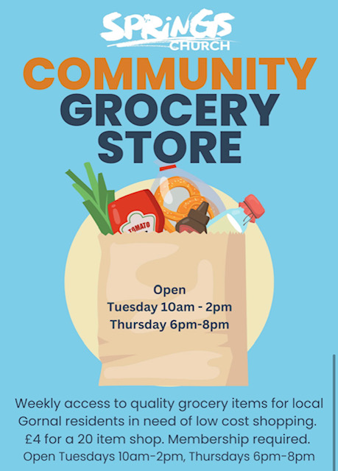
Hope House are going to provide a mini market that stocks non-perishable food items, fresh and frozen food items and non-food/household items available on a membership, low cost basis.
We aim to reach out to individuals and families who are affected by the Cost of Living crisis, people who are in a long term poverty situation due to low earnings and people who find themselves in a short term crisis who can’t or won’t accept ‘freebies’ but require help.
Opening alongside community cafe on a Tuesday to start with and one weekday evening for those unavailable in the day with the view to adapt/ expand hours as needed.
Clients sign up to be a member with a donation of £5 for 12 months. This allows them to shop 2 times per week at £4 per shop for 20 items across the whole shop but no more than 2 of each items (managers discretion and stock levels can apply).
Debt Advice clients will be offered free 1 year’s membership.
Customers may he referred or present themselves with a need to obtain low cost quality groceries. Only requirement is to feel they need the service AND live or work in the Gornal and surrounding areas.

Although there is a donation required from those accessing the project, this is a non-profit project, and this is simply to ensure peoples dignity and help to contribute to the cost of running to keep it sustainable.
All funds will go back into purchasing stock and keeping the project running.
For further information contact
Maggie Harris & Emma Sealey
maggieharris@springschurch.co.uk
emmasealey@springschurch.co.uk
The project will begin at the end of April 2023

Provision House
Help for the most vulnerable
Will increase access to Provision House Social Supermarket and also furniture and basic item support to people who need the service.
The Social Supermarket ’s a membership-based community project that provides a variety of groceries to families who need to save some money on their food bills.
We have a range of items including fresh, chilled and frozen produce, tins and packets, toiletries and cleaning products. We sometimes have breads and pastries and a few baby products to. The quantity and variety can change from week to week.
Memberships costs £4 per visit, and you will be able to take around £20 of produce. We hope that being a member provides a sense of ownership and stability to our families.
We work closely with trusted agencies to support families for 3 to 24 months. We want to empower people to make positive changes and to let them know they are not alone.
Foodbanks are great in a crisis, but it’s better not to get to crisis point before you receive the help you need. That’s why we support agencies who are already working with families to build resilience.
Find out more at https://www.provisionhouse.co.uk/food-club/
You can also find out more about Provision House Home Starter Packages
https://www.provisionhouse.co.uk/provision-of-items/
for more information contact:
Mark Price
markprice@provisonhouse.co.uk
Tel: 01212853970

Just Straight Talk
Swift Responder
Swift Responder will support people who are unable to heat their homes or who do not have enough money to eat or feed their family, this is a borough wide service – referral based.
Just Straight talk will assess the need and respond.
They may provide a supermarket voucher, or help to top up a pre-payment meter, a referral to other bill support if payment is via direct debit.
If a person is struggling with accessing white goods JST can help to apply for funding.
Other services from Just Straight Talk will include referral to other projects to help people become self-sufficient and access other forms of support – reduction of isolation and loneliness projects – referral to HAF, employment support, education and training, links to CAB, advice around money management and many more.
For more information contact Natty or Kate at Just straight Talk (This is a service for people who are most in need).
Natty Hulson
07486433419
Email: Natty Hulson nattyjst@gmail.com
Email: Kate Beale kate@juststraighttalk.org

Dudley Community Information Directory
You can find out more about Dudley’s Community offer at https://dudleyci.co.uk/

Coronation Big Lunch for Councils
This year, people across the UK will come together to celebrate the Coronation of Their Majesties The King and The Queen Consort with a Coronation Big Lunch in their communities.
Following support in 2022 for the Platinum Jubilee, councils again have a key role to play and are encouraged to enable as many residents as possible to join the celebrations by:
Spreading the word about the Coronation Big Lunch and how to get involved. Residents can sign up for the free Coronation Big Lunch resources
Reducing red tape for road closures, and make them free where possible
Organising a public Coronation Big Lunch to bring people together
More information can be found linked below.
Resources:
http://www.coronationbiglunch.com/
The Big Lunch:
http://www.thebiglunch.com/
The Big Lunch for councils:
https://www.edenprojectcommunities.com/the-big-lunch/councils
You can also view DCVS’s Webpage for more ideas:
https://www.dudleycvs.org.uk/get-involved-in-celebratory-community-events-during-the-coronation-weekend-6-8-may-2023/

Household Support Fund 2023/24
In April a simple application process for the Household Support Fund 2023/24 will once again be set up. The exact start date and criteria for this have not yet been finalised.
Please go to https://www.dudley.gov.uk/council-community/cost-of-living/household-support-fund/ to keep an eye on updates.
Cost of Living Payments
The government has announced further Cost of Living Payments between spring 2023 and spring 2024.
These payments are:
£301 for people on an eligible low income benefit, to be paid during spring 2023
£150 for people on an eligible disability benefit, to be paid during summer 2023
£300 for people on an eligible low income benefit, to be paid during autumn 2023
£300 for pensioner households, to be paid during winter 2023 to 2024
£299 for people on an eligible low income benefit, to be paid in spring 2024
To find out more visit the GOV.UK cost of living payment webpage
GOV.UK - Cost of living payments 2023 to 2024
You can also find out lots more about Cost of Living National Initiatives at https://www.dudley.gov.uk/council-community/cost-of-living/national-initiatives/

Dudley Council Voluntary Sector March Funding Update
To see the latest DCVS funding update Go to: https://www.dudleycvs.org.uk/marchs-funding-news-2/
The update is split into three parts.
Section A features funders that can support organisations and individuals with the cost-of-living crisis.
Section B features funders with upcoming deadlines. You’ll find funders with a local or regional focus first, and national funders second. The funders are listed in order of deadline date, soonest first.
Section C features funders who welcome applications at any time. Again, you’ll find funders with a local or regional focus first, and national funders second.

Other Funding Opportunities

UK Shared Prosperity Fund 2023 - 2025 - Dudley Voluntary Sector Briefing
When: Monday 3rd April, 10am - 12pm, DY1 building, Stafford Street, Dudley.
The UK Shared Prosperity Fund (UKSPF) is a £2.6bn fund launched as part of the Governments Levelling White Paper in March 2022. In the West Midlands the West Midlands Combined Authority (WMCA) is the lead authority for UKSPF and is devolving funding to local authorities to support the investment priorities of, Communities & Place, Supporting Local Businesses and People & Skills.
Dudley MBC and Dudley CVS are hosting a session for local voluntary and community organisations to hear about plans for Dudley's UKSPF allocation going forward.
Staff overseeing the Dudley UKSPF programme will be on hand to give information on the funding available, priorities for the borough and application processes.
Book onto the event through Eventbrite at
UK Shared Prosperity Fund - Eventbrite
For more information, please contact
Andy Gray at Dudley CVS on 01384 573381. Email: andygray@dudleycvs.org.uk

Easter holiday activities at DB Leisure
Children can keep busy over the Easter break with fun activities taking place across Dudley borough leisure centres and the Dell Stadium.
Find out more about school holiday activities at DB Leisure.
Access the Dudley MBC Bulletin HERE

Free exercise classes during the Easter holidays
Have fun with your kids or grandkids while being outside and getting fit together. What’s more, it costs nothing. That’s the offer being made this Easter by the volunteers behind the Park Active scheme.
Every week, qualified instructors take people of all ages and abilities through a 45-minute exercise session in local parks.
Families are welcome to join in – children must attend with a responsible adult. Then, once you’ve finished, why not visit the playground, have a family game of football, or just enjoy being in the park?
Park Active takes place at:
Stevens Park, Wollescote
Grange Park, Dudley
Buffery Park, Kates Hill
Stevens Park, Quarry Bank
Abbey Street Park, Gornal
Book in advance. For more details go to www.lets-get.com/park-active
Or, if you don’t fancy an organised session, outdoor gyms are located at Netherton Park, Mary Stevens Park in Stourbridge, Silver Jubilee Park in Coseley and Huntingtree Park in Halesowen.
To find out more about health and wellbeing news please access the link below
Health & Wellbeing Bulletin

Do you want to share your offer to the community with other services?
Send your details to costofliving@dudley.gov.uk and we will share your information Just let us know how you help people with the cost of living (what you offer) and any referral details

To sign up to the weekly news roundup contact costofliving@dudley.gov.uk

24th March Updates

Samaritans Celebration Event - Friday 21st April
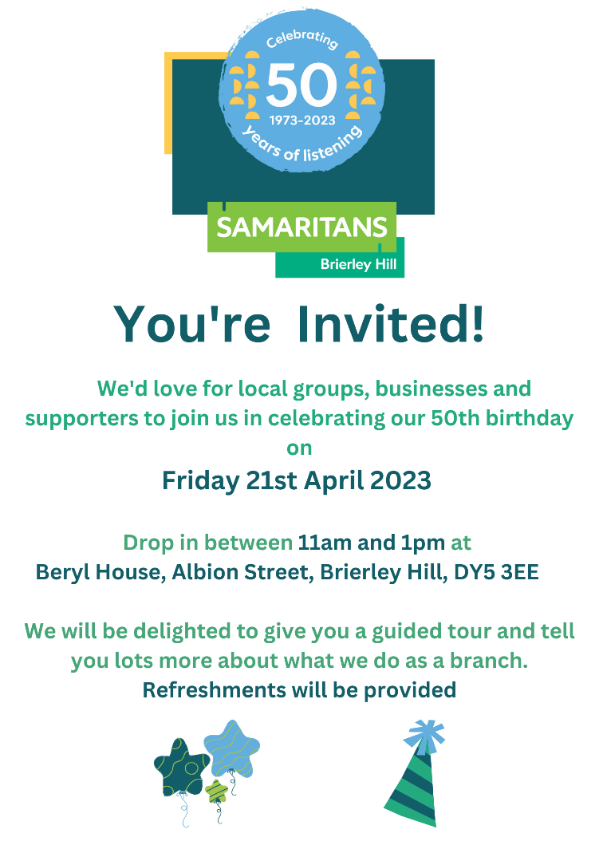

Samaritans at Brierley Hill are inviting local groups, business and supporters to join them for their 50 years celebration.
You are welcome to drop in and find out more about their services at their Brierley Hill Branch on Friday 21st April between 11 and 1pm.
Their branch is located at Beryl House, Albion Street, Brierley Hill DY5 3EE.

Lifetime Webinar – Tough Financial Conversations

We all know that financial conversations are some of the most difficult to have. But within a working environment it can be difficult to navigate the best way.
We’ve bought Andy and Sarah together to host a webinar to talk about tough financial conversations.
It covers

- Why financial wellbeing is important
- What tools you need to have a financial conversation
- How you can empower people to have these conversations
To see why financial wellbeing is important,
read our Autumn/Winter expert report here.

The above webinar has taken place; however you can watch it at your own leisure at: https://www.lifetime-fm.com/march-tough-conversations/

'Building Bridges' For Gypsy, Roma & Traveller communities conference (free to attend)
Rethink Mental Illness & St Margaret’s Community Trust, Unity Hubb are working in collaboration to present a 'Building Bridges' For Gypsy, Roma & Traveller communities conference.
Gypsy, Roma, & Traveller communities are marginalised and discriminated against and experience higher than average rates of suicide and mental health problems but lack access to support and services for a multitude of reasons. Rethink Mental Illness want to connect, engage, and empower existing Gypsy Roma, and Traveller groups and those with a vested interest in supporting these communities to come together with Rethink Mental Illness, for us to share knowledge and resources. To work together to reduce mental Ill health stigma and improve access to Mental & Physical health support.
Location:
Birmingham City Football Club St. Andrews Stadium, Cattell Rd, Birmingham B9 4RL – free carpark (KOP carpark)
Date
Wednesday 29th March 2023,
Time:
9:30 am - 2:00 pm

You can find the agenda in the word document below.
To book a place and or reserve a service stand please email Michaila.Tope@rethink.org


Dudley Easter Holidays HAF Programme
The Dudley Easter Holiday Activities will be starting soon!
If you have not registered, you can find out how to register at https://holidayactivitiesindudley.com/about/
Booking is now open - activities will take place this Easter between 31st March -16th April. There will be lots to choose from.
The aim of HAF is to make free places available to children aged 5-16 who are eligible for benefits-related free school meals because they are a low income family.
In Dudley DCVS have worked with parents, children, young people and schools to ask what they want and need from HAF. The people that will benefit from HAF (you) have been at the heart of our planning and preparation.
If your child is eligible for benefit related free school meals, is aged between 5 and 16 and is a resident or attends school in Dudley borough please register your child.

Change into Action – Alternative Giving Scheme.
Change into Action is an alternative giving scheme that supports specialist charities and street teams working to change the circumstances of people experiencing homelessness or rough sleeping.
It is a partnership between Dudley Metropolitan Borough Council, the West Midlands Combined Authority and many organisations and public-sector bodies that are working across Dudley. Donations are received and held by Dudley Council for Voluntary Services (DCVS) and then shared among trusted, local partners that support people who are rough sleeping, or are at risk of rough sleeping.
All donations go directly to supporting people at risk.
Some of the heroes behind the scenes
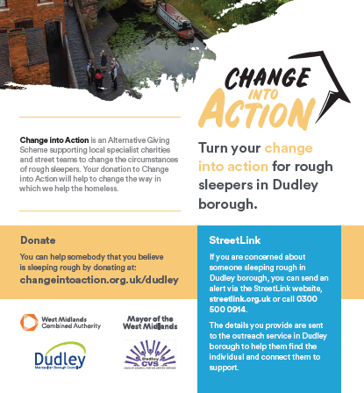
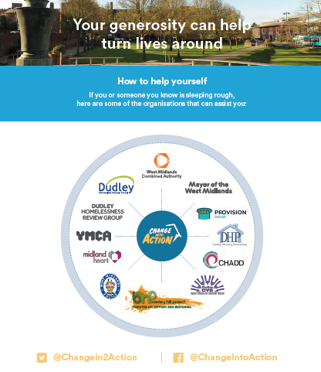
Without a network of services and dedicated charities, it is difficult for any help that is provided to make long term changes. Here are just some of the heroes behind the scenes and the work they do. Find out more at https://changeintoaction.org.uk/dudley/about/

Places where Kids Can eat for free or £1.00 during Easter break: https://moneysavingcentral.co.uk/kids-eat-free



Just Straight Talk’s Launch of a New Project “Full Circle”
This project has been designed for people in Dudley aged 23+, whose alcohol intake is negatively impacting their health and life.
This includes problem drinkers, binge drinkers, alcoholics (including high functioning), and individuals who are alcohol dependent. Just Straight Talk are offering advice and guidance to help people reassess their relationship with alcohol. The support will be tailored to meet individual needs and circumstances and will include
- Lived experience – mentoring role
- Modelling – engaging with health services and the benefits
- Peer / buddy support around positive physical and mental wellbeing
- Advice and guidance around building a better future (filling the void of alcohol) including employment, training, and achievable life goals)
- Debt advice, benefit advice, budgeting, financial advice and guidance.
- Support with appointments
- Signposting to housing, employment and other advice and guidance and other services when ready such as counselling and or addiction support
If you would like further information regarding this new project, then please contact Just Straight Talk on 01902 256744 or e-mail info@juststraighttalk.org
To find out more about other services Just Straight Talk offer go to https://www.facebook.com/JustStraightTalk/

​I am just a bit Stressed: Anxiety, Moral Injury & Vicarious Trauma
Black Country Staff Mental Health & Wellbeing Hub are hosting a 'Take Time to Look After Yourself' programme of monthly webinars to benefit the wellbeing of staff working across the Black Country ICS. Our next session in April is titled 'I am just a bit stressed: Anxiety, moral injury & vicarious trauma'.
This session will be delivered by Principal Clinical Psychologist Dr Nicola Rose and we will explore:
- The differences between anxiety, moral injury & trauma
- How to spot the differences to ensure the right support for health & wellbeing

As with all of our webinars in this series, we will include time for a Q&A and a beneficial peer discussion.
Monday 3rd April 1pm-2:30pm - https://stressed1.eventbrite.co.uk
Tuesday 11th April 6pm-7:30pm - https://stressed2.eventbrite.co.uk
These sessions are available to all staff working in the Black Country ICS including NHS Staff, Local Authority, Social Care, Care Home, Primary Care staff and staff within all other health and social care roles across the Black Country area.

Funding Opportunities
Dudley Councils Forum Grants –find out more at
https://www.dudley.gov.uk/council-community/your-home-your-forum/forum-grants/
Dudley CVS Funding News - https://www.dudleycvs.org.uk/februarys-funding-news-2/

Energy bills support extended for an extra three months
The Chancellor of the Exchequer, Rt Hon Jeremy Hunt MP, announced today (15 March) that the Energy Price Guarantee will be extended for three months.
The Energy Price Guarantee will be kept at £2,500 for an additional three months from April to June, saving a typical household £160. Energy prices are 50% lower than forecast in October, but remain high, with this support helping bridge the gap to lower prices forecast from the end of June.
Announcement: https://www.gov.uk/government/news/energy-bills-support-extended-for-an-extra-three-months

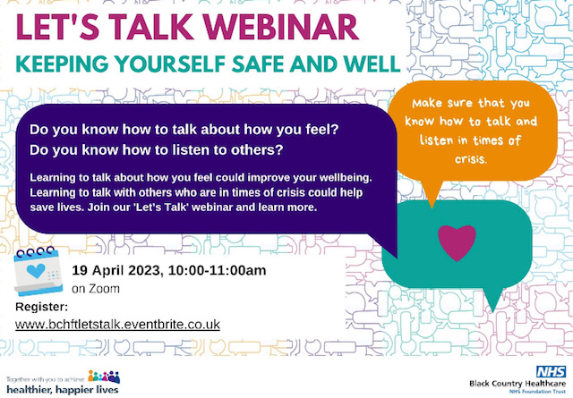
Let’s Talk Webinar – Keeping yourself safe and well!
Do you know how to talk about how you feel?
Do you know how to listen to others?
Learning to talk about how you feel could improve your well-being.
Learning to talk with others who are in times of crisis could help save lives. Join our 'Let’s Talk' webinar and learn more.
The event will be held on Zoom please use the link to register below
Let’s Talk Webinar – Keeping yourself safe and well
Please let us know if you have any accessibility requirements by emailing bchft.communications@nhs.net

Do you support people who are struggling with finances, and this is impacting other areas of their life such as their wellbeing, job and education opportunities etc?
Do you want to share your offer to the community with other services?
Send your details to costofliving@dudley.gov.uk and we will share your information Just let us know how you help people (what you offer) and any referral details

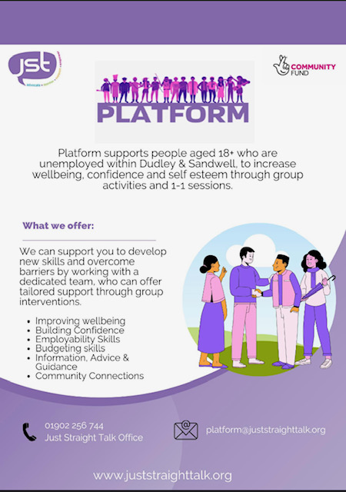
Just Straight Talk’s new project “Platform”
Platform is a new project set up by Just Straight Talk!
The project support people aged 18+ who are unemployed within Dudley & Sandwell.
The project will work with people to increase their wellbeing, confidence and self esteem through group activities and 121 sessions.

A dedicated team will help with
- Improving wellbeing
- Building confidence
- Employability skills
- Budgeting skills
- Information, advice and guidance
- Community Connections
To find out more contact the Just Straight Talk office on 01902 256744 or email platform@juststraighttalk.org

Black Country Foodbank Impact Report
“Foodbanks are incredible spaces where providing a food and toiletry parcel is only the beginning. Often there is additional support ranging from debt advice to clothing and furniture, helping people with their immediate needs but also tackling the root of the crisis. The figures that you will read in this report are staggering, but please remember that these figures are only the tip of the iceberg. There are many more people who are not accessing Foodbanks or help from charities because of fear, pride or lack of knowledge. The levels of poverty run much deeper than this report conveys” (Jen Coleman, CEO BCFB).
You can find the report at Black Country Foodbank Impact Report

Free Essential Skills Digital Course
This qualification is designed for adults with limited experience of using digital devices and the internet.
Please find attached further information in the word document.
The course will take place at

Castle and Priory NLC, Limes Road. Dudley DY1 4AQ

Monday 24th April 2023 - 17th July 2023

9:30 – 3:00.

Contact acl@dudley.gov.uk to find our more or register.


Black Country Wellbeing Centre Free Bostin Breakfast for over 50s!
Do you live in the Upper Gornal Area?
Are you over 50 and want to connect with other people?
Why not go along to the Black Country Wellbeing Centre on a Thursday morning from 10am till 11:30 and get a free breakfast!
You are also welcome to use some of their light exercise and fitness machines too.
Black Country Wellbeing Centre
127 Vale St, Upper Gornal, Dudley DY3 3XQ.

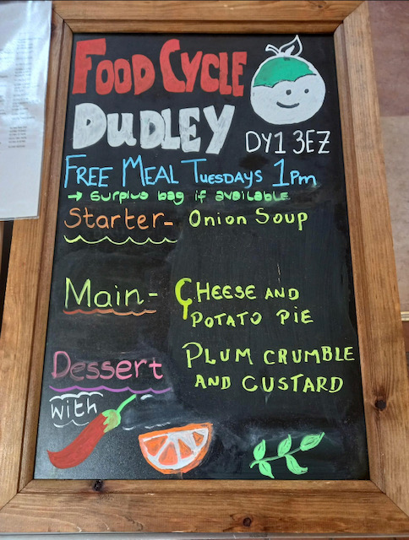
Food Cycle Dudley – Tuesdays at 1pm
Did you know that there is a food cycle at St Francis Church?
Food Cycle provides a free meal every Tuesday.
People are welcome to join them at 1pm.
Menu is different every week!
St. Francis' Church, Laurel Rd, Dudley DY1 3EZ.

CHADD - Easter Egg Drive

Can you support CHADD’s Easter Egg Drive?

CHADD would like donations of Easter Eggs for women and children in their women’s refuge, outreach services, and for young people who have experienced homelessness.
Donations will be greatly accepted at
CHADD, Brindley House, 48-50 Hall St, Dudley DY2 7DT

.

